SmartCare v0.3 – Domain Model Workbook

Requirement-to-Concept Trace
Requirement | Concept | State/Behaviour | Decision
FR-01 – Creating the patient record | Patient | Storing the patient record and the details of the patients for getting stored the patient data | Included
FR-02 – Access to View patient information | Patient | Allowing the staff to view the patient record | Included
FR-03 – Search patient records | Patient | Allowing the record of the patients to be searched | Included
FR-04 –Modify patient information | Patient | Allows patient information to be updated. | Included
FR-05 – Match patient information with practitioner | Patient / Practitioner / Appointment | Providing a connection between the patient and the relevant practitioner of the same field . | Included
FR-06 – Practitioner information and schedule | Practitioner | Stores practitioner details and provides access to the practitioner’s schedule. | Included
FR-07 – Create appointment | Appointment | Stores the data of patient, practitioner and appointment date/time. | Included
FR-08 – View appointments | Appointment | Allows appointment information to be viewed. | Included
FR-09 – Search appointments | Appointment | Allows appointments to be searched. | Included
FR-10 – Update/reschedule appointment | Appointment | Allows appointment details and time to be updated. | Included
FR-11 – Cancel appointment | Appointment | Changes the appointment status to cancelled while keeping the appointment record. | Included
FR-12 – Prevent Double booking of patient | Appointment / Practitioner | Check whether the practitioner is booked for what timings and creating new bookings accordingly | Included
NFR-01 – Security | Staff/System | Patient and clinic data must be managed securely. | Included as a system requirement
NFR-05 – Accurate and consistent data | Patient / Practitioner / Appointment | Data should remain accurate and consistent when records are created or changed. | Included

CRC Cards

Patient
Responsibilities
- Storing the patient information and details in the system
- Create a space in the system consisting of the patient record
- Access to view the patient information and the old past records of the patient
- Easy access for searching the patient information in the system
- Easy modification of the data of the patient.
Collaborators
- Appointment
- Staff

Practitioner
Responsibilities
- Store practitioner information.
- Store practitioner ID and name.
- Access to the practitioners schedule
- Be associated with appointments.
- Check availability of the practitioners to help prevent double booking.
Collaborators
- Appointment
- Patient
- Staff

Appointment
Responsibilities
- Store appointment information.
- Store appointment ID, date/time and status.
- Connecting a patient to a practitioner.
- Create appointments.
- View appointments.
- Search appointments.
- Modify the Appointments
- Cancel appointments.
- Check practitioner availability to prevent double booking.
Collaborators
- Patient
- Practitioner
- Staff

Optional Class

Staff
Responsibilities
- Create and manage patient records.
- Search and update patient information.
- Create and manage appointments.
- Access information required to perform clinic tasks.
Collaborators
- Patient
- Practitioner
- Appointment
Reason for optional class:
Staff is also one of the important class of the system as staff is the only class which creates, manages and update the data of the system and keep the system functioning

UML Class Diagram
You can draw the following classes and relationships in your UML diagram.

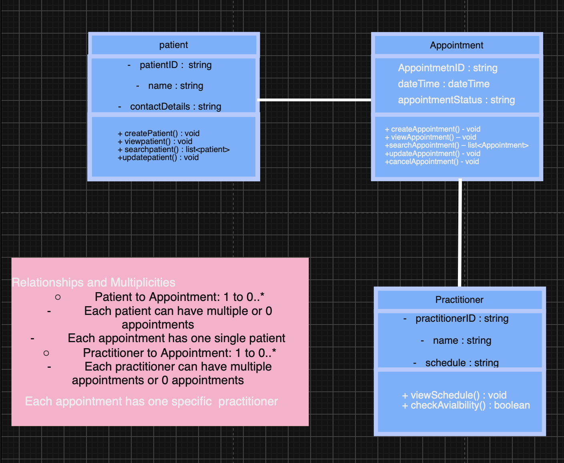

Relationships and Multiplicities
- Patient 1 → 0.. Appointment*
One patient can have zero or many appointments. Each appointment belongs to one patient.
- Practitioner 1 → 0.. Appointment*
One practitioner can have zero or many appointments. Each appointment is assigned to one practitioner.
- Appointment → Patient and Practitioner
Each appointment connects exactly one patient with exactly one practitioner.
- Double booking rule:
A practitioner cannot have two appointments at the same date and time.

Design Rationale
I selected Patient, Practitioner and Appointment as the main classes because they are directly supported by the confirmed SmartCare requirements. Patient is responsible for providing his details to staff for creating their record in the system and for creating an appointment, while Practitioner represents their schedule and the relative field and get connected to the patient as per their schedule and the field. Appointment is the main class of SMART CARE system acting as intermediate between the patient and the practitioner
The responsibilities of the class are provided to them as per their information such as the patient class holds the data of the patient records and their appointment records meanwhile the Practitioner class holds the data of their schedules and their field and at class the appointment class holds the data of the match of the patient and the practitioner appointment and store the date/time details of both of them.
The main components are the patient, practitioner and the appointment. A single appointment must have a patient and a practitioner meanwhile the patient or the practitioner can have the multiple appointments as well
The features like the SMS and the online payment are not been included in the system as these features were not in the requirement list of the client and in cases if these features were added in the system they would be counted as the unwanted features provided to the system .

AI Design Review Record
AI suggestion | Evidence | Decision | Reason | Model change
Create a Patient class. | FR-01, FR-02, FR-03, FR-04 | Accepted | Patient information is a major part of the confirmed requirements. | Added Patient as a core class.
Create a Practitioner class. | FR-05, FR-06, FR-12 | Accepted | Practitioner information, schedules and availability are required. | Added Practitioner as a core class.
Create an Appointment class. | FR-07, FR-08, FR-09, FR-10, FR-11, FR-12 | Accepted | Appointment management is a confirmed part of SmartCare. | Added Appointment as a core class.
Add a Staff class for all staff functions. | FR-01–FR-04 and FR-07–FR-11 | Modified | Staff perform many functions, but the requirements do not define detailed staff data or behaviour. | Kept Staff as an optional class rather than a core class.
Add an SMS Notification class. | No confirmed requirement | Rejected | SMS reminders were suggested by AI but are not supported by the current requirements. | No model change.
Add an Online Payment class. | No confirmed requirement; outside current scope | Rejected | Online payment is not part of the SmartCare system scope. | No model change.
Add an AI Treatment Recommendation class. | No confirmed requirement; outside current scope | Rejected | The current system does not require AI-generated treatment recommendations. | No model change.

Final modelling decision
The Final Smart Care System model consist of the three classes which are Patient, Practitioner, Appointment. The staff class is considered as the optional class because staff is one of the class which is managing all the three other class but it itself cannot be considered as the main class as it is dependent on the other classes, there is no sort of staff required if there would be no patient, practitioner or the appointments in the system.

